2025 Disability:IN Global Conference

*Sponsored by:*  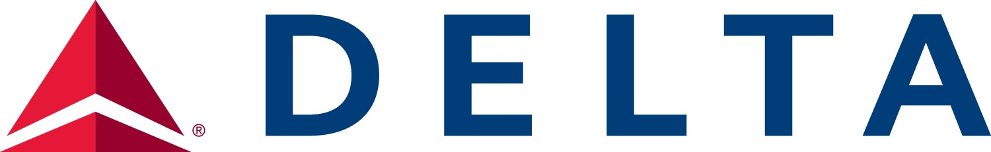

# Social Toolkit for Attendees

We’re thrilled to be together soon in Orlando, Florida for this year’s Global Conference! Please utilize this toolkit to spread the word and connect with fellow attendees.

## Registration Link

<https://disabilityin.org/2025conference/>

## Recommended Hashtags:

#DisabilityInclusion #AreYouIN? #INfor2025

## Sample Posts:

**LinkedIn/Instagram/Facebook**

* I’m so excited to attend this year’s @Disability:IN Global Conference in Orlando! This year, Disability:IN has a fantastic agenda full of insights from industry leaders, world class networking, engaging breakout sessions, and so much more!

If you are attending, I’d love to connect! If you’re not signed up yet- there's still time to register at <https://disabilityin.org/2025conference/.> #AreYouIN?

* I’m thrilled to be joining @Disability:IN at their 2025 Global Conference in Orlando! Join me for the opportunity to learn from #DisabilityInclusion leaders, expand your network, gain early access to new research, and more! If you’re also attending, let me know as I’d love to connect!

Register for this year’s Global Conference at <https://disabilityin.org/2025conference/!> #AreYouIN?

* I could not be more excited to connect with our customers/clients at this year’s @Disability:IN Global Conference in Orlando! With a packed agenda and networking opportunities with business leaders from all around the globe, this is a conference you do not want to miss!   
     
  Join me by registering at <https://disabilityin.org/2025conference/> #AreYouIN?

**Threads/X**

* I’m thrilled to be attending this year’s @Disability:IN Global Conference in Orlando! If you’re attending, let’s connect. If you haven’t registered, you can learn more at <https://disabilityin.org/2025conference/> #AreYouIN?
* Join me in Orlando this July for @Disability:IN’s 2025 Global Conference! I’m excited to learn from industry leaders, make new connections, and gain insights on brand new research! Register today at <https://disabilityin.org/2025conference/.> #AreYouIN?

Social Graphic:

Download the social graphics [here.](https://www.dropbox.com/scl/fo/frue8cn7v1c38puj6ft7t/AP3OdH6WC03Kt-WynHcLSdA?rlkey=bzpbqtlu343iz9qy3ml9kxsxd&st=v2fkyczu&dl=0)

Customizable Social Graphic & Social Frames:

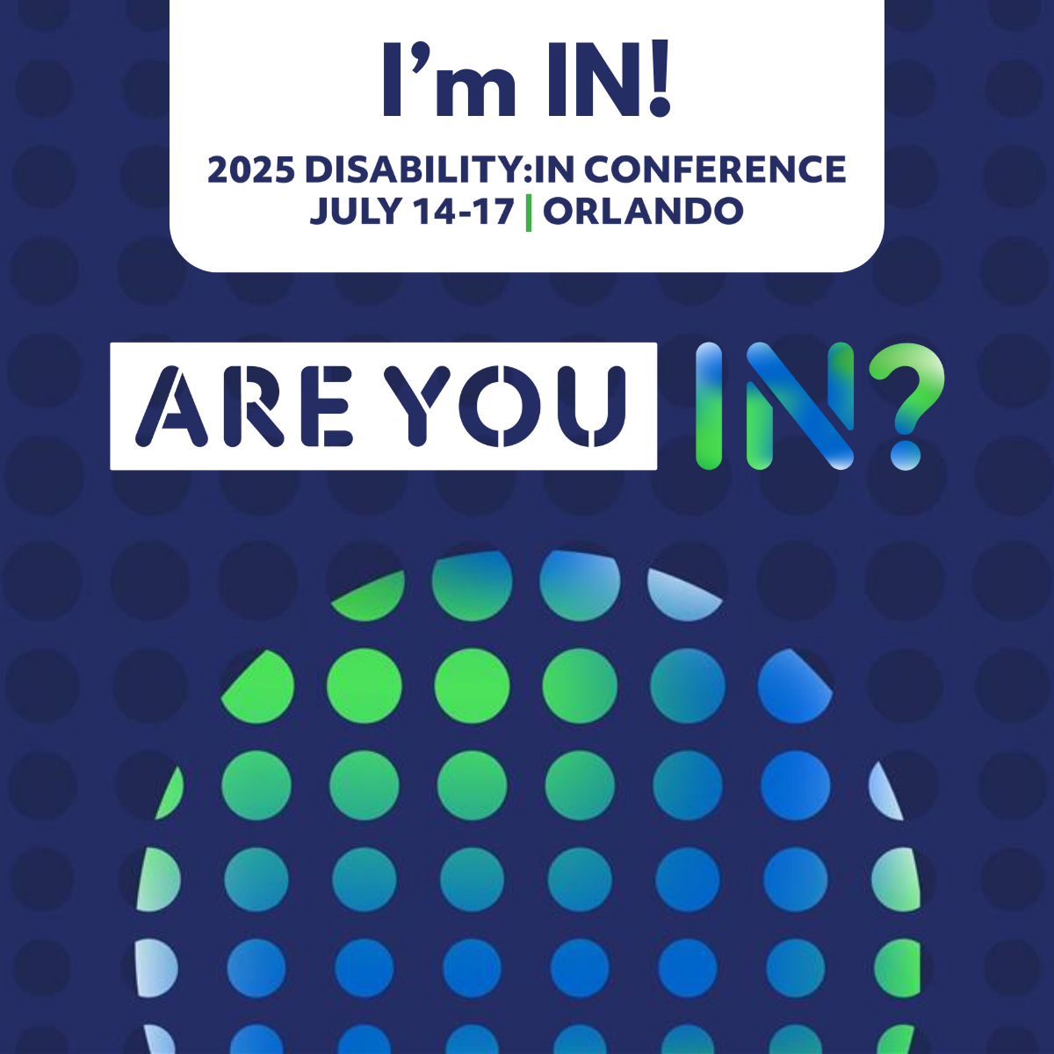 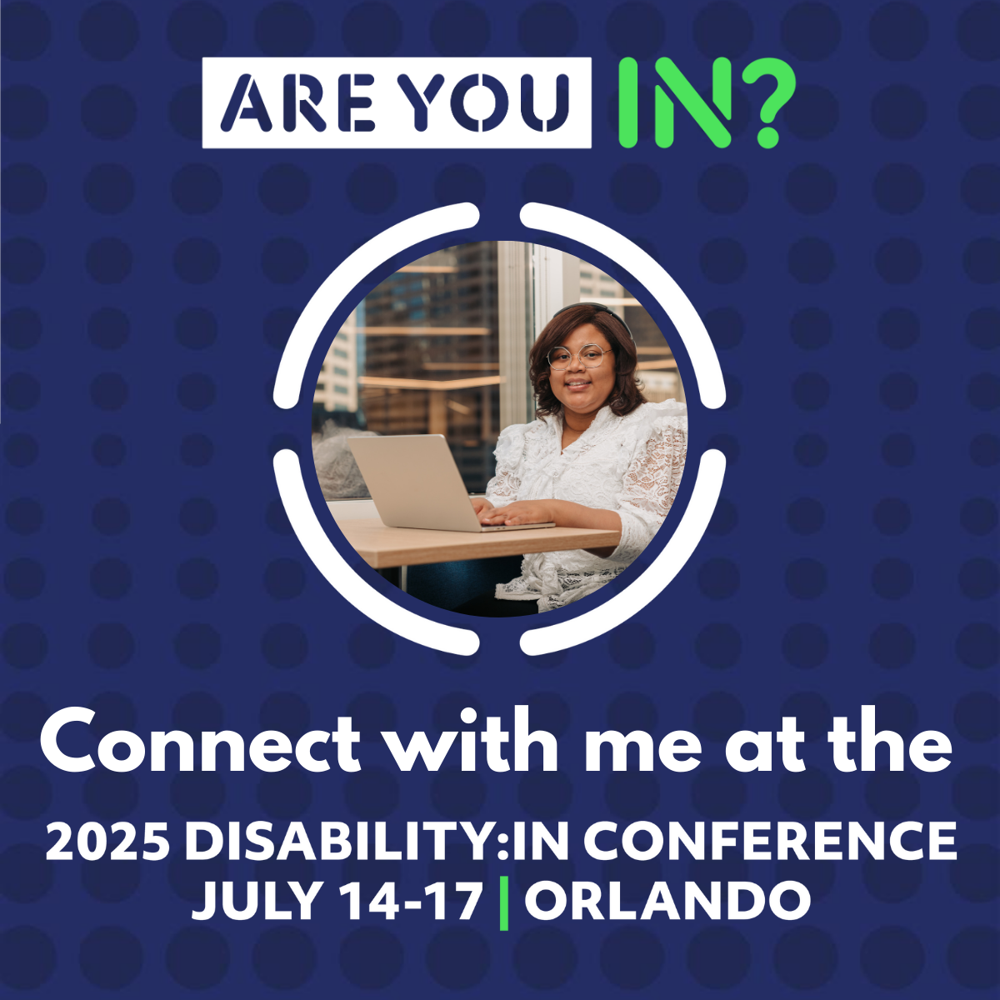

**To download the customizable social graphic...** [Visit Canva](https://www.canva.com/design/DAGkzW7fMpE/tLWo__o5mkliYNh3Skd5_Q/view?utm_content=DAGkzW7fMpE&utm_campaign=designshare&utm_medium=link&utm_source=publishsharelink&mode=preview), click “Use Template”, upload your headshot, click-drag into the available frame. Once loaded into the graphic, download it by navigating to the “Share” button at the top right and download a PNG file!

## Remember to add Alt Text!

## Social Graphic Alt-Text: [A blue dotted backdrop with a blue green gradient circular pattern in the bottom center. Above is the text I'm IN! 2025 Disability:IN Conference July 14-17 | Orlando. Below is the Are You IN? Logo.]

## Customizable Social Image Alt-Text: [A blue dotted backdrop behind an image with four white lines bordering it. The image is of [INSERT YOUR DESCRIPTION HERE]. Below is the text Connect with me at the 2025 Disability:IN Conference July 14-17 | Orlando. In the top center is the Are You IN? logo]

## Please note, some channels impose character limits on alternative text. For more information, or if you’re unsure about how to make image content inclusive by inserting alternative text, check out our resource on creating disability [inclusive & accessible media posts.](https://disabilityin.org/resource/creating-accessible-social-media-content/) For platform-specific information, please check out the following:

## [Adding alt-text on LinkedIn](https://www.linkedin.com/help/linkedin/answer/109799/adding-alternative-text-to-images-for-accessibility)

## [Adding alt-text on Twitter](https://help.twitter.com/en/using-twitter/picture-descriptions)

## [Adding alt-text on Facebook](https://www.facebook.com/help/214124458607871)

## [Adding alt-text on Instagram](https://www.facebook.com/help/instagram/503708446705527)

## Tag Us on Social!

Tag us across Social so we can engage with and amplify your posts!

LinkedIn [@Disability:IN](https://www.linkedin.com/company/disabilityin/)

Instagram [@DisabilityIN](https://www.instagram.com/disabilityin/)

Facebook [@DisabilityIN](https://www.facebook.com/DisabilityIN)