International Day of Persons with Disabilities

Resource & Communications Toolkit
As International Day of Persons with Disabilities approaches on December 3, Disability:IN is excited to offer a variety of ways for your company to join IN the celebration. Explore this toolkit, filled with different resources to help you get involved and spark conversations across your teams and network.

Ways to Join IN

Custom Trainings & Speakers
Strengthen your team’s approach to disability inclusion in December and beyond. Disability:IN offers customized trainings and expert speakers who deliver actionable insights to support your business goals. No matter where you’re at in your disability inclusion journey, we have a solution that’s right for you.
Explore our custom solutions and secure your session now.

Join IN
Disability:IN partners with leading companies and drives progress through initiatives, tools, and expertise that deliver long-term business impact. Are You IN? Learn how to partner with us.

Join the Conversation on Social Media

Sample Posts:
- This International Day of Persons with Disabilities (#IDPWD), we recognize the global disability community and the business imperative of building workplaces where everyone can thrive.
Today, I encourage you to check out @Disability:IN’s suite resources, benchmarking tools, and research on why #DisabilityInclusion creates workplace that work for everyone. https://disabilityin.org/
- On International Day of Persons with Disabilities, we celebrate the innovation and leadership people with disabilities bring to the workplace. If you’re looking for resources to advance disability inclusion at your company, I highly recommend checking out @Disability:IN free resource library here: https://disabilityin.org/resources
- International Day of Persons with Disabilities reminds us that disability inclusion is a global business priority. Companies embed disability inclusion and #accessibility across their enterprise are better positioned for long-term success. Learn more about the business case for disability inclusion at https://disabilityin.org/data-and-insights. @Disability:IN #IDPD

Hashtags:
#IDPD #IDPWD #DisabilityInclusion #AreYouIN?

Social Graphics:
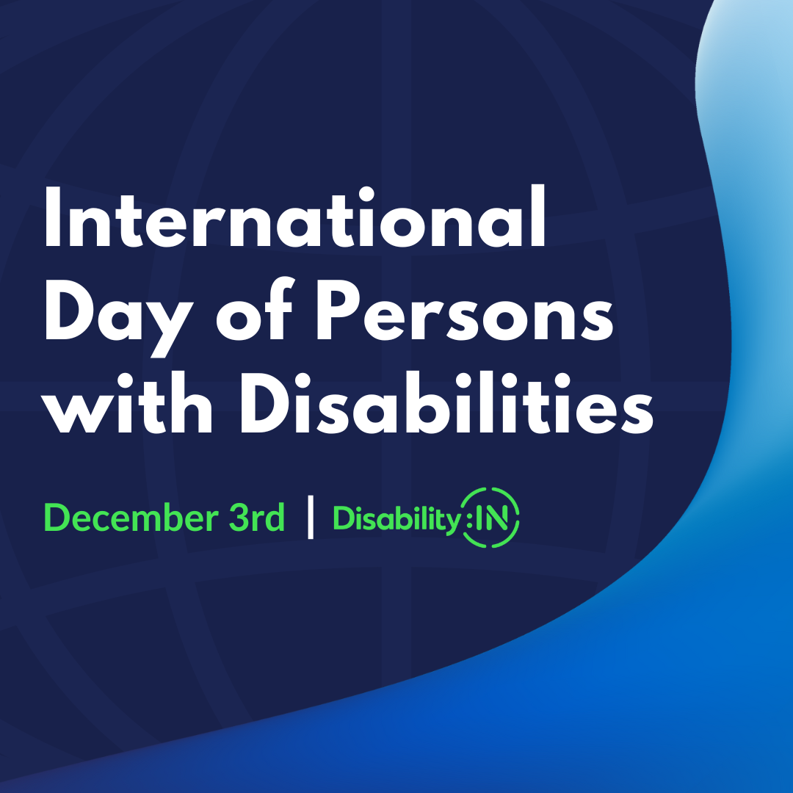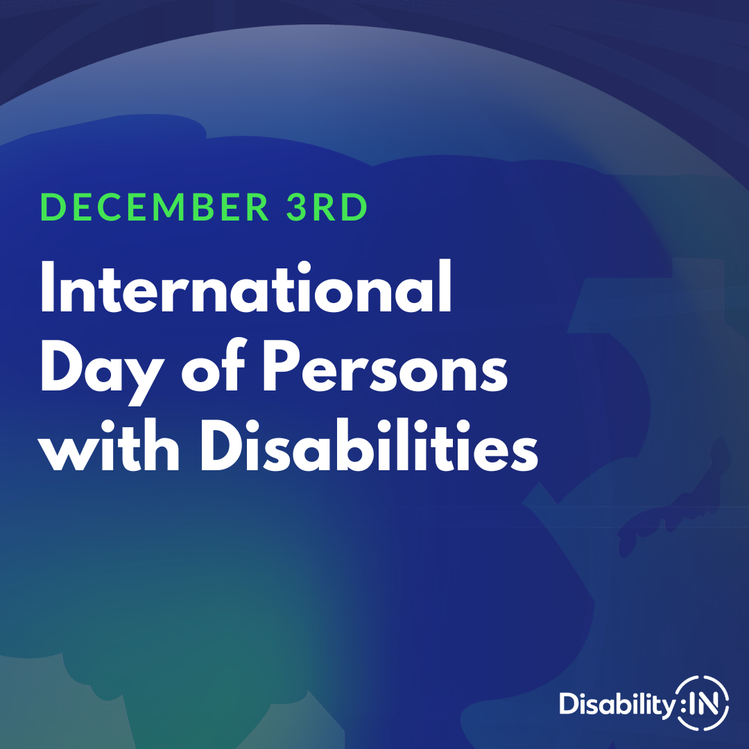

Download the social graphic here.

Remember to add Alt Text!
Graphic 1: A blue background with faded lines depicting a globe behind the text International Day of Persons with Disabilities December 3rd | Disability:IN. To the right is a blue gradient wave reaching from the bottom left corner to the top right.
Graphic 2: A gradient globe focused on the APAC region containing text December 3rd International Day of Persons with Disabilities. In the bottom right is the Disability:IN logo.

Please note, some channels impose character limits on alternative text. For more information, or if you’re unsure about how to make image content inclusive by inserting alternative text, check out our resource on creating disability inclusive & accessible media posts. For platform-specific information, please check out the following:
- Adding alt-text on LinkedIn

Adding alt-text on X

Adding alt-text on Facebook

Adding alt-text on Instagram

Tag Us on Social!
Tag us across Social so we can engage with and amplify your posts!

LinkedIn @Disability:IN

Instagram @DisabilityIN

Facebook @DisabilityIN

